Sree Sankara Vidyapeetom College
Alumni Association
Annual Report – 2020-21
Alumni Association of Sree Sankara Vidyapeetom College has always been pioneer and motivational to the campus since its inception. Various activities have been organized in departmental as well as college level during the academic year 2020-21 as part of “ENRICHING THE CAMPUS” program. The college campus remain closed during the year 2020-21 due to Covid-19 pandemic restrictions. All the academic activities were shifted to digital platforms and online gatherings. But these pandemic restrictions could never slow down the pace of alumni activities in the campus.
The Alumni association of Sree Sankara Vidyapeetom College has organized various online programs and activities during the academic year 2020-21.
Commerce Alumni Association
- Commerce Alumni Association conducted an open forum on the topic “BEING A STUDENT ALWAYS” as a part of observance of World Students Day on October 15, 2020. The resource person, also alumni of SSV College, was Sri. Varghese Joy, Asst. Professor, Rajagiri College of Social Science.
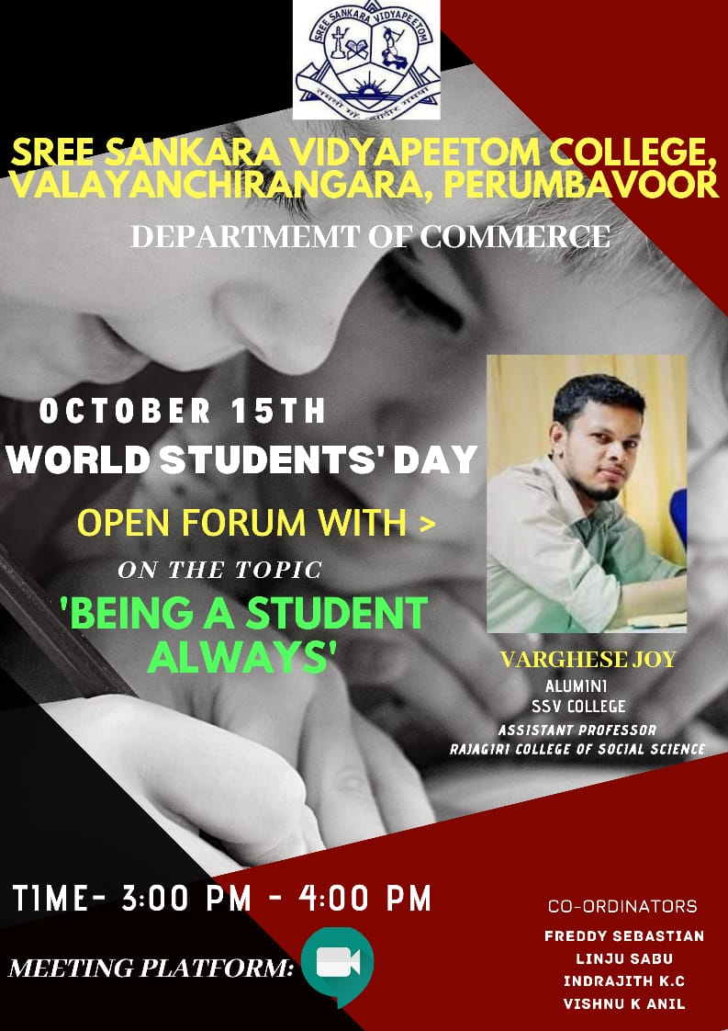

- Department of Commerce in association with ED Club, IIC & IEDC and College Alumni Association organized a Start Up workshop on “Dream it and Do it” on 29.05.2021 at 2.00 pm. The meeting platform was Google meet and there were 99 participants attended the program. The resource person for the session was Sri. Unnikrishnan V. K. ( Managing Director, Garga M Commerce Private Limited & Founder, G Taste Homely Taste). The meeting was presided by Dr. Padma P, Principal, SSV College. Welcome address was given by Dr. Resmi R. (HoD, Commerce) followed by presidential address. Felicitations were given by Dr. Manusankar C., (College IQAC Coordinator) & Adv. Arun N. (President, College Alumni Association). The meeting was ended with the vote of thanks proposed by Sri. Freddy Sebastian (Association Secretary, Dept. of Commerce).
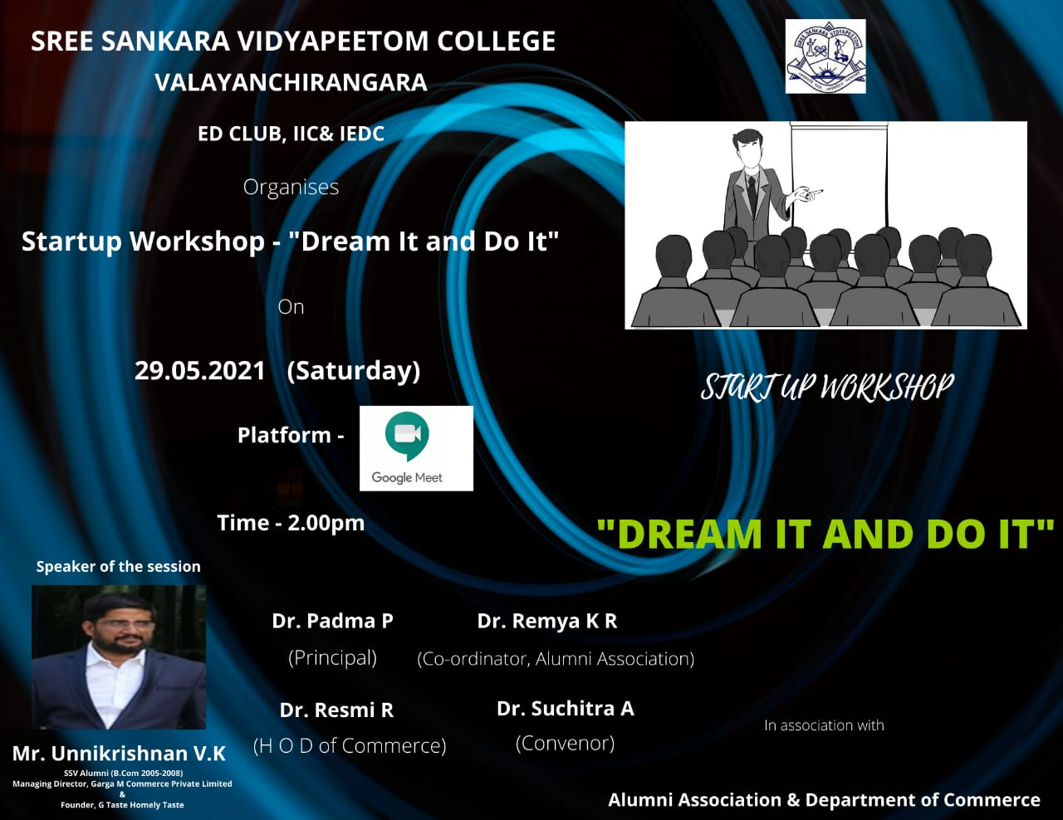
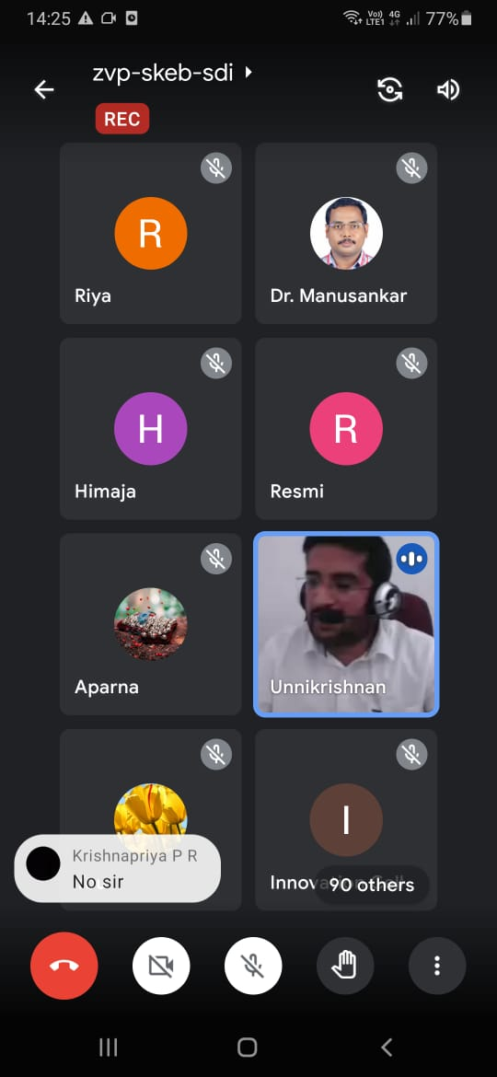 | 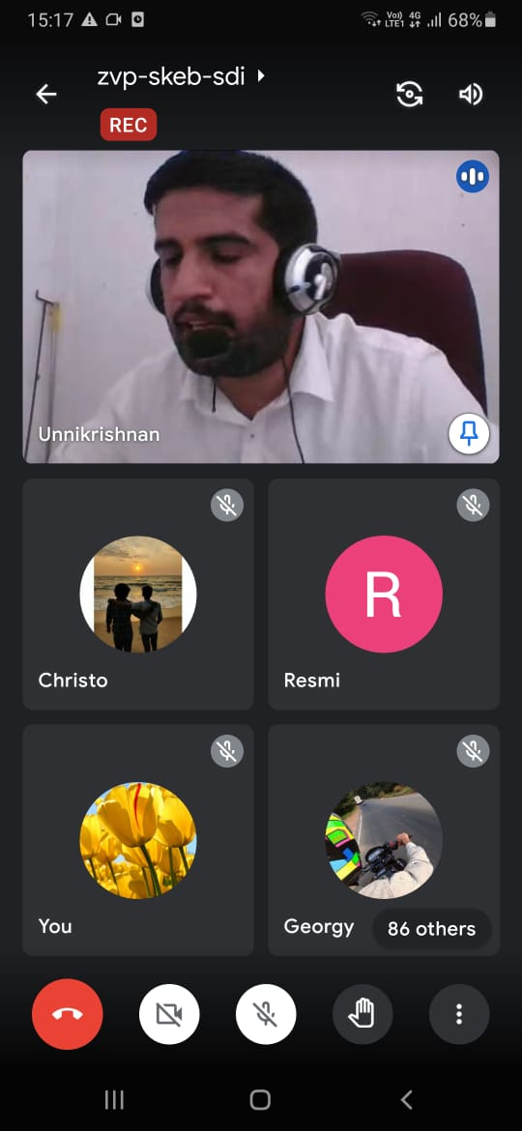

Physics Alumni Association
- Dept. of Physics in association with College Alumni association conducted a webinar on the topic “Cyclones in Indian Ocean: Facts and Effects “on 20.05.2021. The resource person was alumni of the college, Ms. Devika M. V (M. Sc Meteorology, MTech in Atmospheric Sciences, CUSAT). The program was presided by College Principal Dr. Padma. P. Welcome speech was delivered by Dr. Bindu K. R. (HoD, Dept. of Physics) College Alumni president Adv. N Arun and secretary Adv. K. R. Sunilkumar delivered felicitations. College Alumni association coordinator Dr. Remya. K. R delivered the vote of thanks. 100 participants including students, teachers and alumni attended in this program.
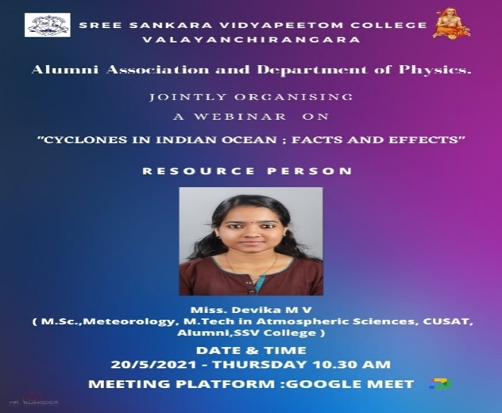
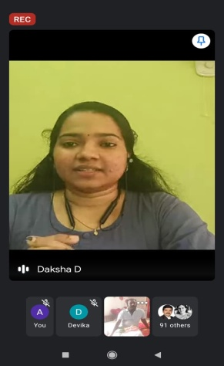 | 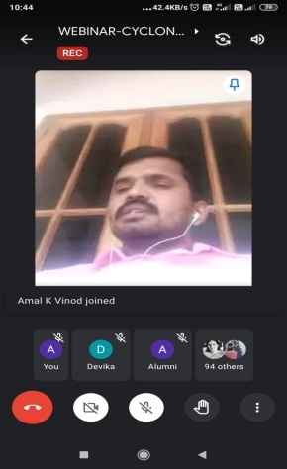 | 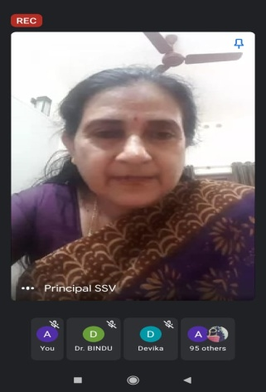 | 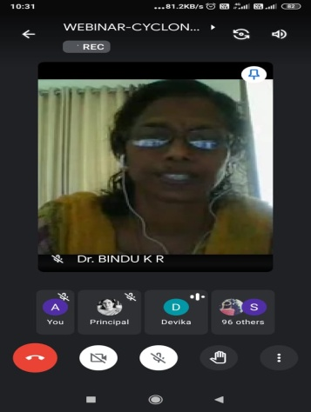

Chemistry Alumni Association
Department of Chemistry, SSV College in Association with Alumni Association and Institution Innovation Council organized a webinar on 29th May, 2021 at 11 am. The resource person for the session was Smt. Deepa Mohanan, Judicial First Class Magistrate, Court I, Thiruvananthapuram (B.Sc. Chemistry Alumni (1999-2002). Meeting platform was Google meet and there were 95 participants attended the program. The meeting was presided by Dr. Padma P, Principal, SSV College. Welcome address was given by Smt. Anju Paul, Asst. Professor, Department of Chemistry followed by presidential address. Felicitations were given by Adv. K.R Sunil Kumar (Secretary, SSV College Alumni Association), Smt. Sumi K.S (Co-ordinator, Institution Innovation Council) and Sri. K. V Neelakandan (Office Superintendent). The Webinar was on the topic “Intellectual Property Rights”. The meeting was ended with the vote of thanks by Ms. Ameena K. S (Student representative)
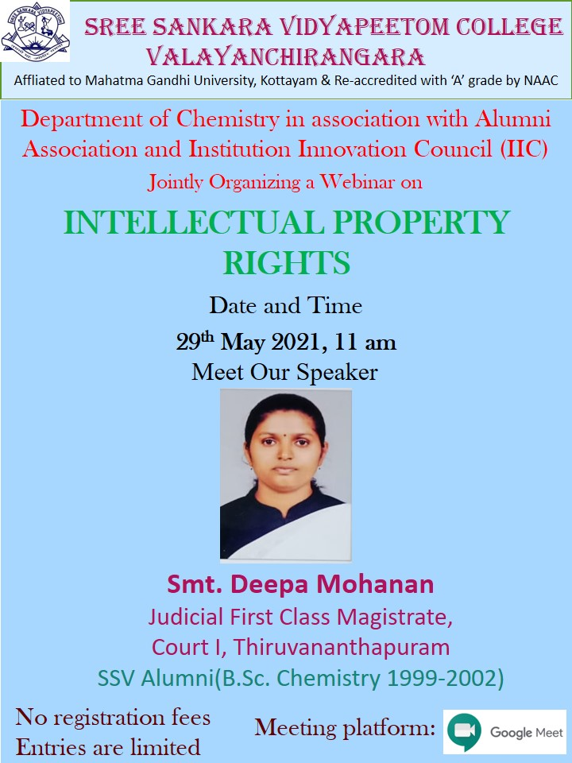

Computer Science Alumni Association
Post Graduate Department of Computer Science in Association with Alumni Association organized a webinar on ”An Overview of Film Editing” on 03rd June, 2021 at 02.30 pm. The resource person for the session was Sri. Aravind Jayan, Film Student at Film and Television Institute of India (FTII). Meeting platform was Google meet and there were 98 participants attended the program. The meeting was presided by Dr. Padma P, Principal, SSV College. Welcome speech was given by Dr. Prathibha P H, Asst. Professor & Program Coordinator, Department of Computer Science followed by presidential address. Felicitations were given by Dr. Manusankar C, (HoD & IQAC Coordinator) and Adv. N Arun (President, SSV College Alumni Association). The Webinar was on the topic “An Overview of Film Editing”. The meeting was ended with the vote of thanks by Dr. Remya. K. R (College Alumni association coordinator).
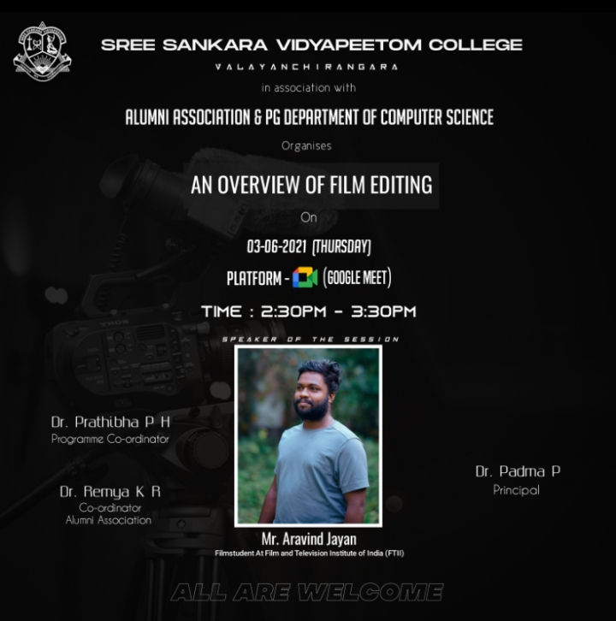

English Department Alumni Association
A three-day workshop on “Our Society, Our Responsibility” was organized under the auspices of Alumni Association and the Department of English, Sree Sankara Vidyapeetom College, Valayanchirangara, from 9-6-2021 to 11-6-20219 (Wednesday- Friday). It was scheduled on Google Meet at 5.30 P.M. All the three Resource Persons of this programme, Ms. R. Sarika, Mr. ArunKumar M. S and Ms. Namitha Rajeev, were the Alumni of the department. On the first day of this programme Ms. R. Sarika (Counsellor, Minds Counselling and Training Centre) rendered a talk on “Maintaining Mental Health at the Time of Covid”. Mr. ArunKumar M. S (Medical and Psychiatric Social Worker, AIMS, Kochi) enriched the participants with a lecture on “Social Isolation and Depression among the Elderly in the context of Pre and Post Covid19: A Global Change” on the second day. Then on the third day Ms. Namitha Rajeev (Trainer, Youth 4 Jobs Foundation) delivered a talk on “Citizen’s Responsibility and Approach towards Society with special reference to Vulnerable Groups”. Dr. Padma P, Principal, SSV College, inaugurated and presided over the workshop. On these three days she presided over the function and rendered presidential address. Welcome speech was delivered by Smt. Sheena Kaimal N, Dr. Sreekala P. S and Dr. Chandrika V. N respectively. Dr. K. M. Sudhakaran (Member, Syndicate, Mahatma Gandhi University & HOD, Department of Political Science), Adv. N. Arun (President, Alumni Association), Dr. Manusankar C (HOD, Dept. of Computer Science & IQAC Coordinator), Dr. Remya K. R (Coordinator, College Alumni Association) and Sri. Viswan M. G (Asst. Professor, Dept. of Commerce & NSS Program Officer) joined to render felicitation. Vote of thanks was proposed by the first year students Ms. Parvathy S, Mr. Mathews K Saji and Ms. Sharafiya K. N on the first day, second day and third day respectively. The poem “Kadalassu Poovenkilum” by Dr. Geetha Namboothirippad (faculty, Dept of English) was recited on the third day. Jeophine, II BA English, was the master of the ceremony.
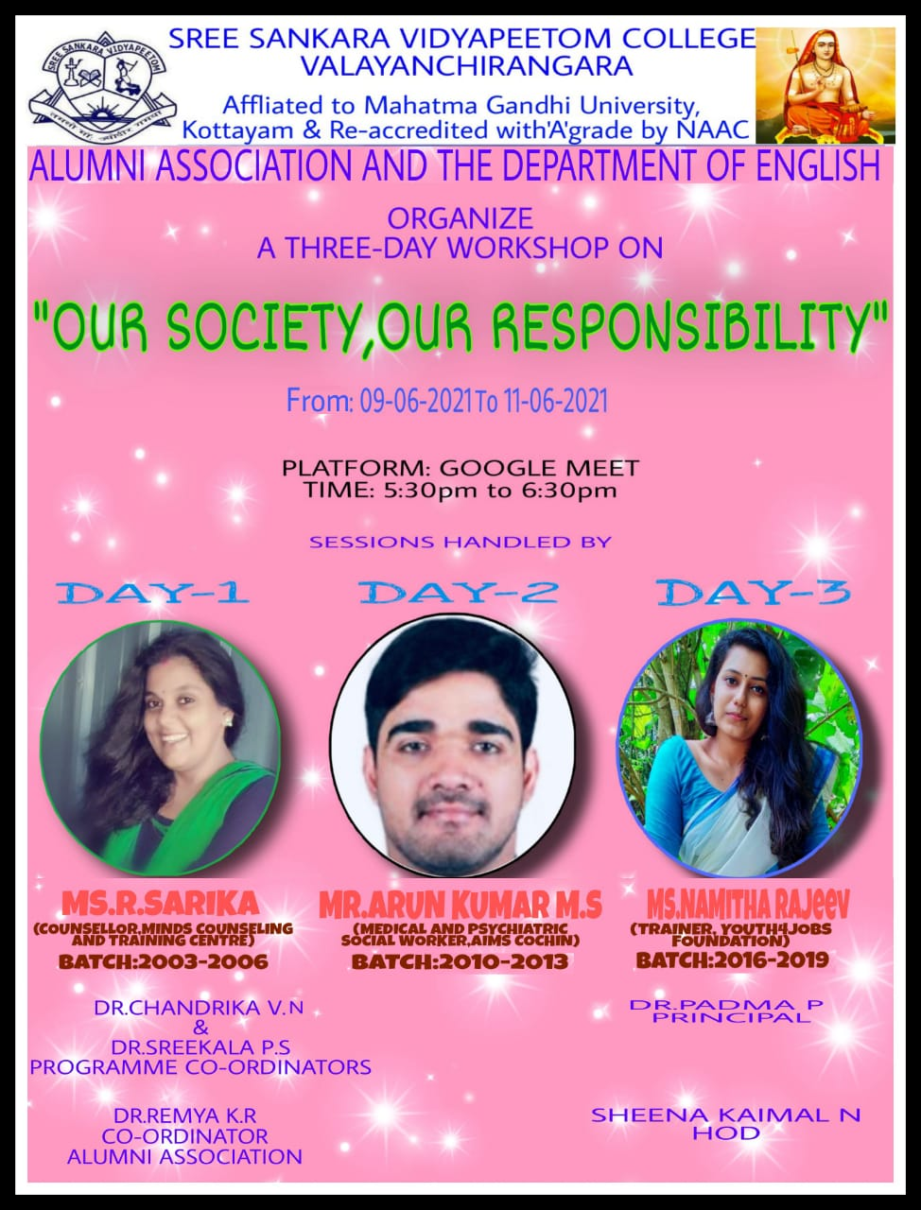
Workshop – Day-1
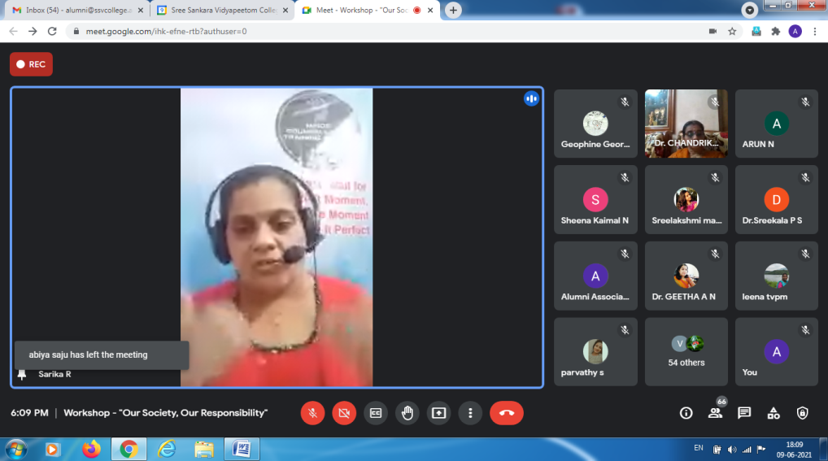
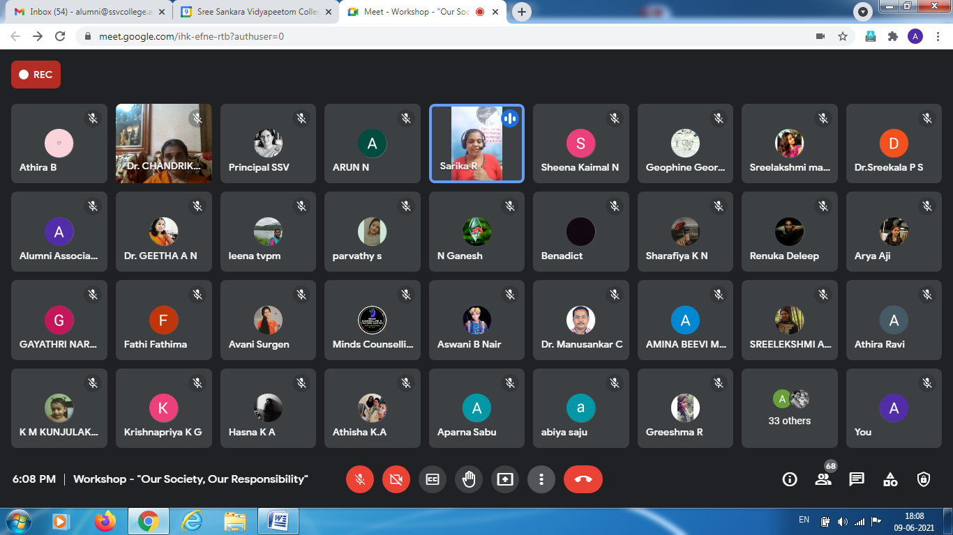
Workshop – Day-2
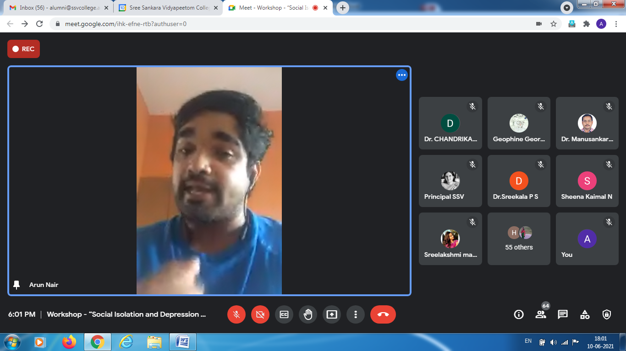
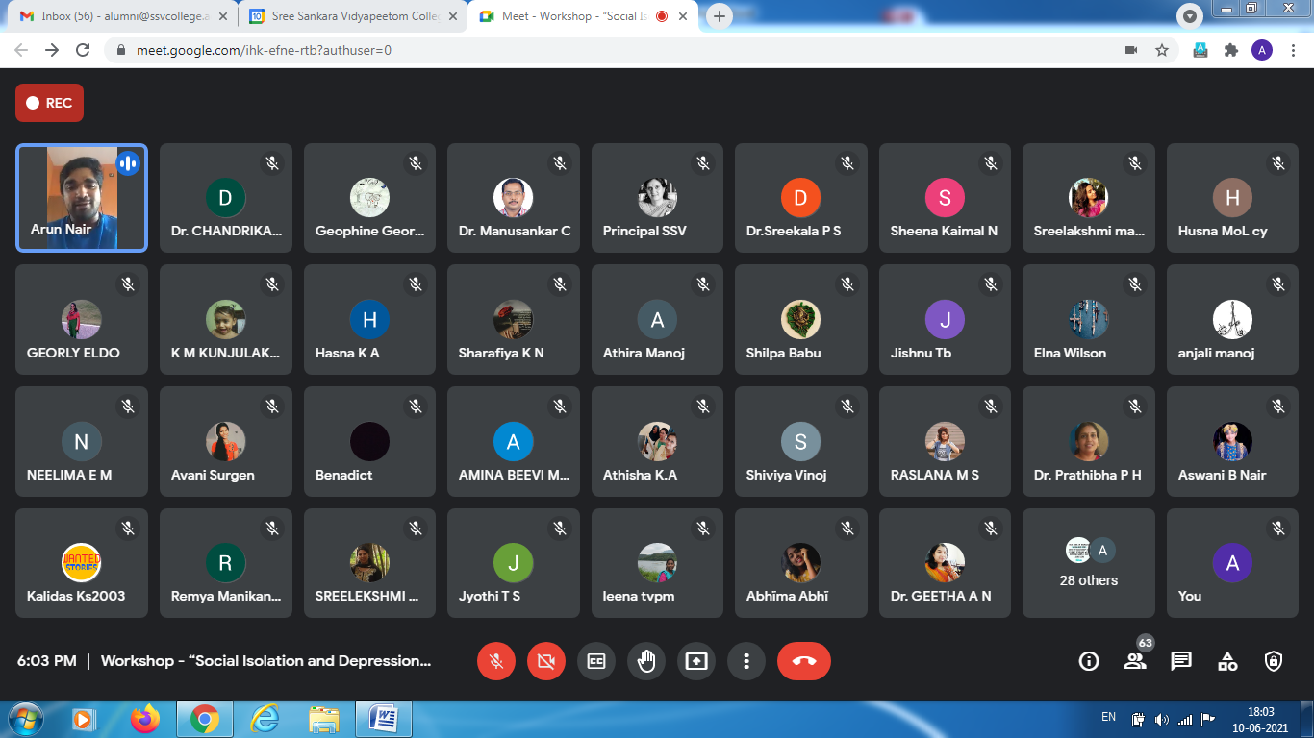
Workshop – Day-3
